**Use environment variables for improving security.**

This is code needs improvement from security point of view this code has sensitive information hard coded which makes it vulnerable, unprotected and attackable

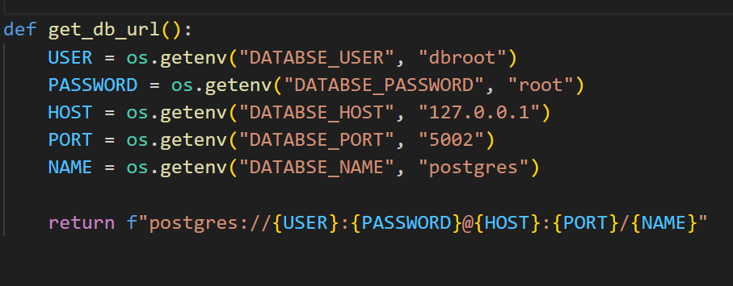

in this example image this is not a best practic